Rocks
Rock Cycle
Igneous Rocks
Sedimentary Rocks
Metamorphic Rocks
Highlighted colors are from previous unit. Not sure if they’ll need to know it, too. So, do what you wish with the material.

1. What are rocks?

- Rock: Solid materials composed of ________________________________

  - ________________: rock composed of two or more minerals mixed together

  - ________________: rock composed of a single mineral

2. How are rocks classified?

- Rocks are classified based on ________________________________ (see ESRT page 6: Rock Cycle in Earth’s Crust)

3. How do rocks form?

- The Rock Cycle: the continuing change from one rock type to another rock type over a very long period of time (ESRT page 14)

- ____________ Rocks: formed from ____________and ____________of magma/lava

- ____________ Rocks: ____________________________________________ of sediments

- _______________Rocks: formed from any rock type due to extreme ______and _______

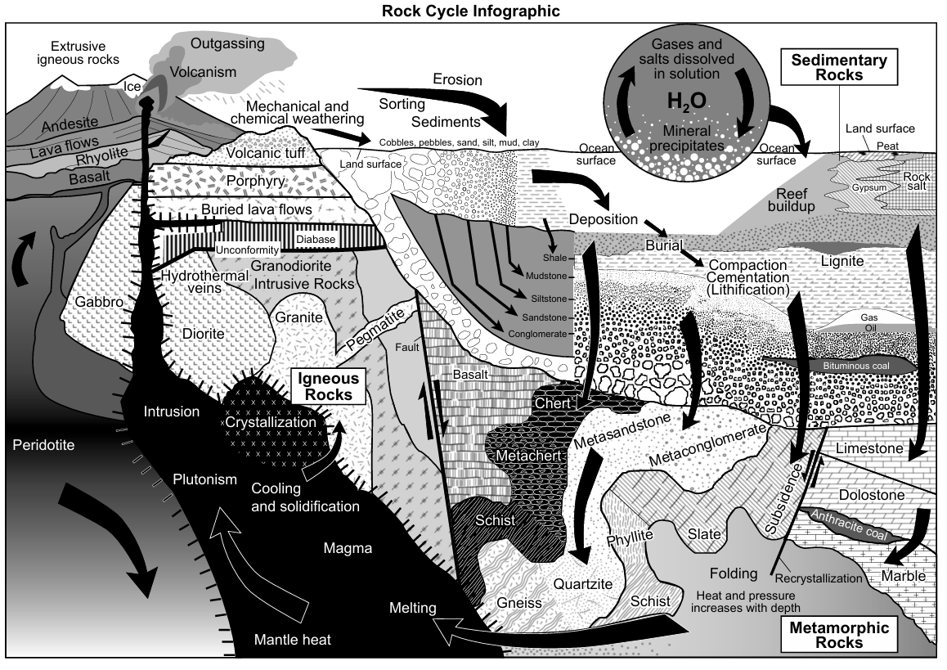

4. What are igneous rocks?
- Igneous Rocks: rocks formed by the solidification of molten material (magma or lava)

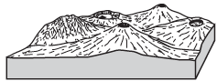

5. What are the two locations igneous rocks can form?

Extrusive | Environment of Formation | Intrusive
 | Also Known As…
 | Location
 | Rate of Cooling
 | Size of Crystals
 | Texture
 | Examples

- ____________: a rock with _______________(holes) formed when gas bubbles became trapped in rapidly cooling lava

6. What are igneous rocks composed of?

- Chemistry of Igneous Rocks: depends upon the presence of certain elements

 | Dominating Elements
 | Composition
Light color | Color | Dark color
Low density | Density | High density
Obsidian (color exception)  Pumice  Granite | Examples | Basalt  Gabbro

7. What are the key features of an igneous rock?

 | 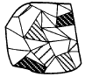 | 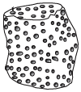

- Checkpoint – Igneous Rock Identification:

- The flowchart below shows the formation of some igneous rocks. Letters A through I indicate parts of the flowchart that have not been labeled. Using your knowledge of igneous rocks and ESRT page 6, fill in the blanks for letters A through I.

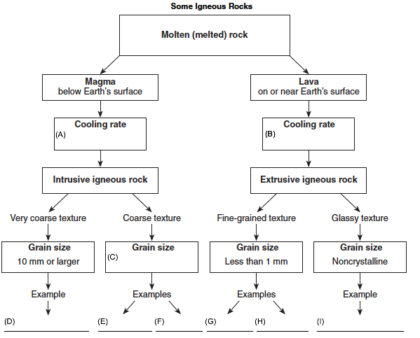
- The photograph below shows actual crystal sizes in a light-colored igneous rock that contains several minerals, including potassium feldspar, quartz, and biotite mica.
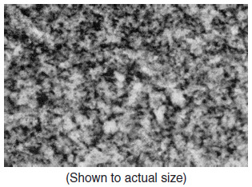

Which rock should this be identified as? ___________________________________________

- The diagrams below show the crystals of four different rocks viewed through the same hand lens. Which crystals most likely formed from molten material that cooled and solidified most rapidly?
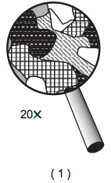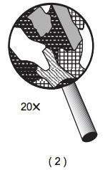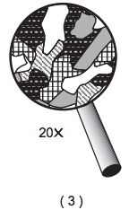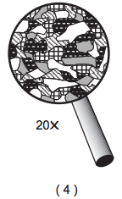

- What is the name of the extrusive, non-vesicular igneous rock with a fine texture and a mineral composition of 35% quartz, 35% potassium feldspar, 15% plagioclase feldspar, 10% biotite, and 5% amphibole?

- Which rock most probably formed directly from lava cooling quickly at Earth’s surface?
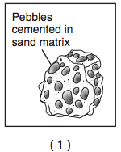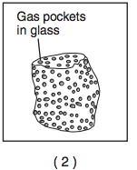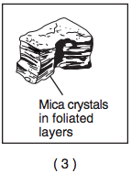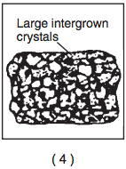

8. What are sedimentary rocks?

- Sedimentary Rocks: rocks formed from the weathering and erosion of rocks into sediments and the deposition, burial, compaction, and cementation of those sediments

  - Sediments: small fragments of rock (see ESRT pg 6 top right for sediment names & sizes)
  - Weathering: ________________________ into smaller particles
  - Erosion: process that _____________________ to a new location
  - Deposition: when sediments are ____________in a new location. Most sediments are eventually deposited on the seafloor
  - Burial: sediments are __________by other sediments
  - Compaction: Sediment particles are ________________ and joined together
  - Cementation: Minerals dissolved in water act as a cement, ______________________

9. How and where do sedimentary rocks form?

- Sedimentary rocks are formed in _____________________, typically in the ocean.

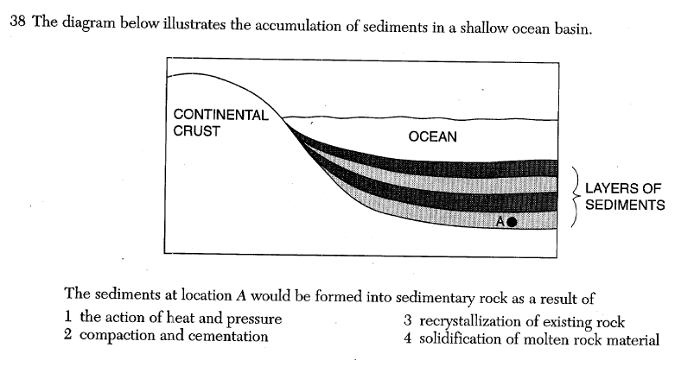

10. What are the key features of sedimentary rocks?

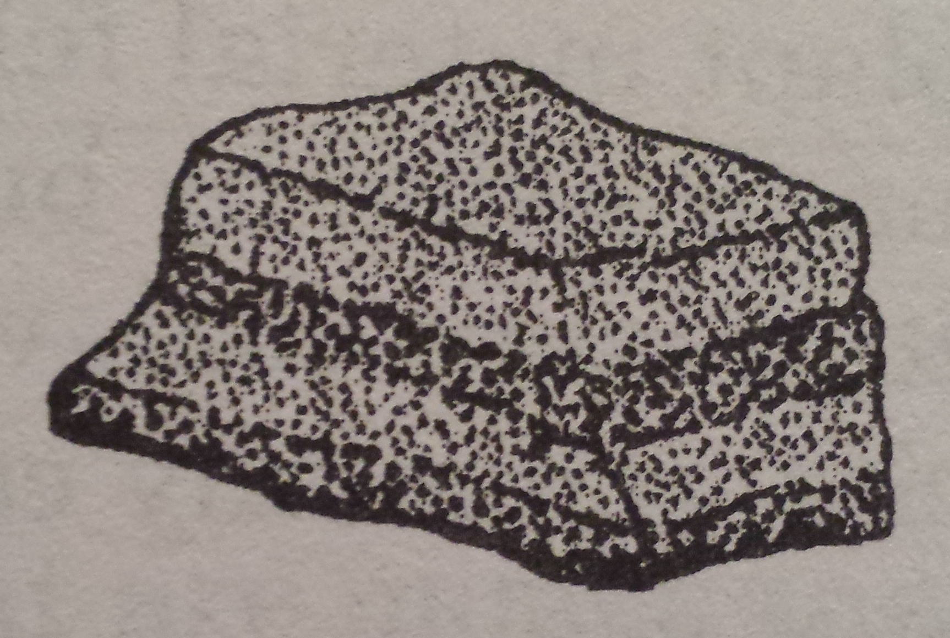 | 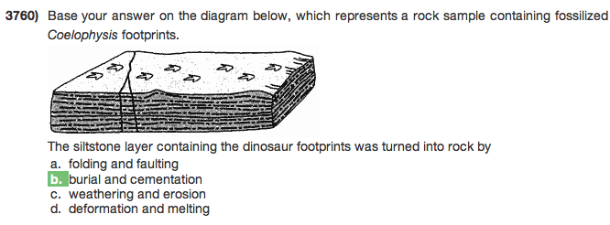 | 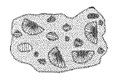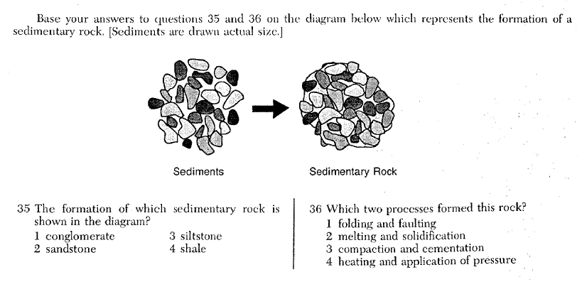

11. What are the three types of sedimentary rocks?

- ________________________: rocks made from sediments joined together after deposition, burial, compaction, and cementation

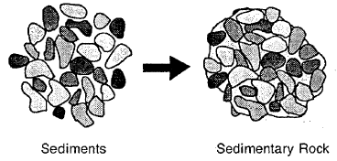

Classification: Clastic rocks are classified based upon their grain size.

- Shale is made of __________________________________________________________.
- Siltstone is made of ________________________________________________________.
- Sandstone is made of ______________________________________________________.
- Conglomerate and breccia are made of ________________________________________. Conglomerate and breccia are different because _________________________________
________________________________________________________________________.

- ________________________: rocks that form when water containing dissolved mineral ________________________________________________

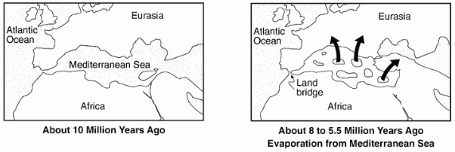

Classification: Chemical rocks are classified based upon their mineral composition.

- Rock salt is composed of ___________________________________________________.
- Rock gypsum is composed of _______________________________________________.
- Dolostone is composed of __________________________________________________.
- Limestone is composed of __________________________________________________.

- ________________________: rocks that form from the remains of living things
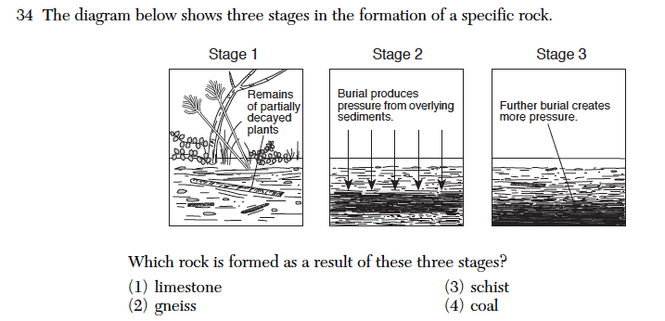
Classification: Bioclastic rocks have different mineral compositions and formed from different types of organisms.

- Limestone is composed of ______________________ and formed from ______________ _______________________________________________________________________.
- Bituminous coal is composed of ______________________ and formed from _________ _______________________________________________________________________.
- Checkpoint – Sedimentary Rock Identification

- Base your answers to questions i through vii on the drawings below which show six sedimentary rocks labeled A through F.
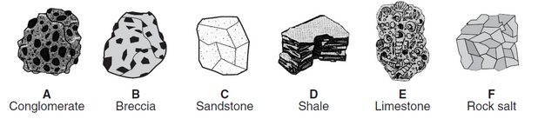
- How are rocks A through D similar? ______________________________________________ ___________________________________________________________________________
- How are rocks A, C, and D different? _____________________________________________ ___________________________________________________________________________
- How are rocks A and B different? ________________________________________________
- What is the mineral composition of rock E? ________________________________________
- What is the mineral composition of rock F? ________________________________________
- Describe the process by which rock F formed. ______________________________________ ___________________________________________________________________________
- Which rock would bubble when in contact with acid? _________________________________
- The sequence of diagrams below represents the gradual geologic changes in layer X, located just below Earth's surface.
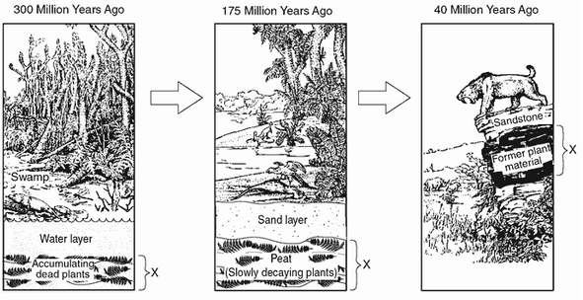

Which type of sedimentary rock was formed at layer X? _________________________________

- The cross section shows a portion of Earth’s crust. Letters A, B, C, and D represent rock units that have not been overturned.
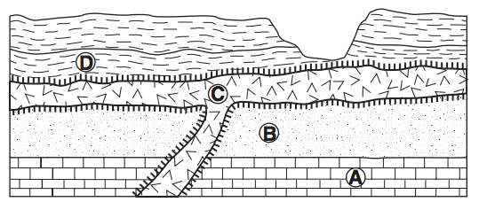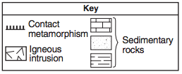
Name the sedimentary rock layer A, B, and D.

A: ______________________ B: ______________________ D: ______________________

- The diagram below represents a rock sample containing dinosaur footprints.
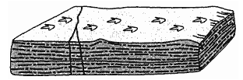

Why must this be a sedimentary rock? _____________________________________________
____________________________________________________________________________
12. What are metamorphic rocks?

- Metamorphic Rocks: formed directly from any type of rock under extreme heat and pressure

- You must know how to use ESRT page 14.

13. What are the changes that occur in rocks due to metamorphism?

- ____________________ of unmelted material

- ________________________

- ________________________

14. What are the two types of metamorphic rocks?

- ___________: __________________ of mineral crystals

- ___________: the light-colored and dark-colored bands of minerals that form parallel to the foliation

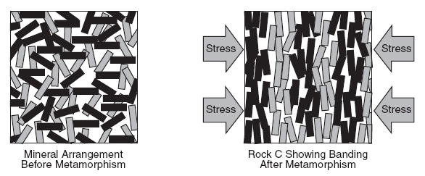
- _________________: ______________________ of mineral crystals

15. What is the key feature of a metamorphic rock?

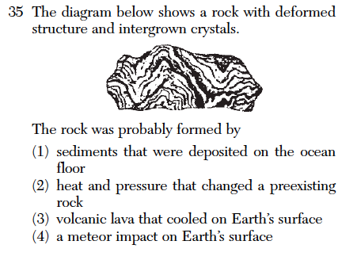

16. What are the two types of metamorphism?

- ___________Metamorphism: occurs when ______________________ are under intense ______________________; associated with mountain building

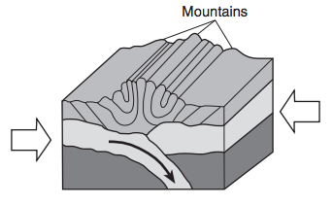

- ___________metamorphism: occurs when molten rock comes in contact with surrounding rock in a ________________

________________: the rock that a metamorphic rock formed from

Example: Molten rock (igneous intrusion) causes limestone in zone A to metamorphose into ______.

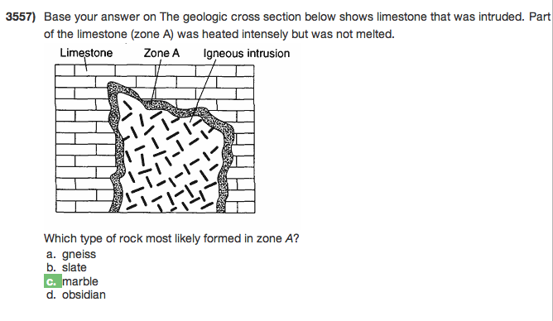

- Checkpoint - Metamorphic Rock Identification:

- The diagram below represents a sample of a rock.
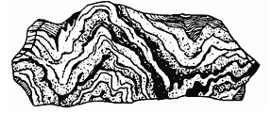
Why would this be classified as a metamorphic rock? _______________________________ ___________________________________________________________________________
- A student on a field trip in New York State collected a sample of metamorphic bedrock containing bands of coarse-grained crystals of plagioclase feldspar, pyroxene, quartz, and mica. Identify the metamorphic rock found by the student.

- The cross section shows a portion of Earth’s crust. Letters A, B, C, and D represent rock units that have not been overturned.

Name the metamorphic rock formed when sedimentary rock layers A and B undergo contact metamorphism because of the igneous intrusion C.

A: _________________________________________________________________________

B: _________________________________________________________________________

- The photograph below shows a large outcrop of rock composed primarily of visible crystals of mica, quartz, and feldspar.
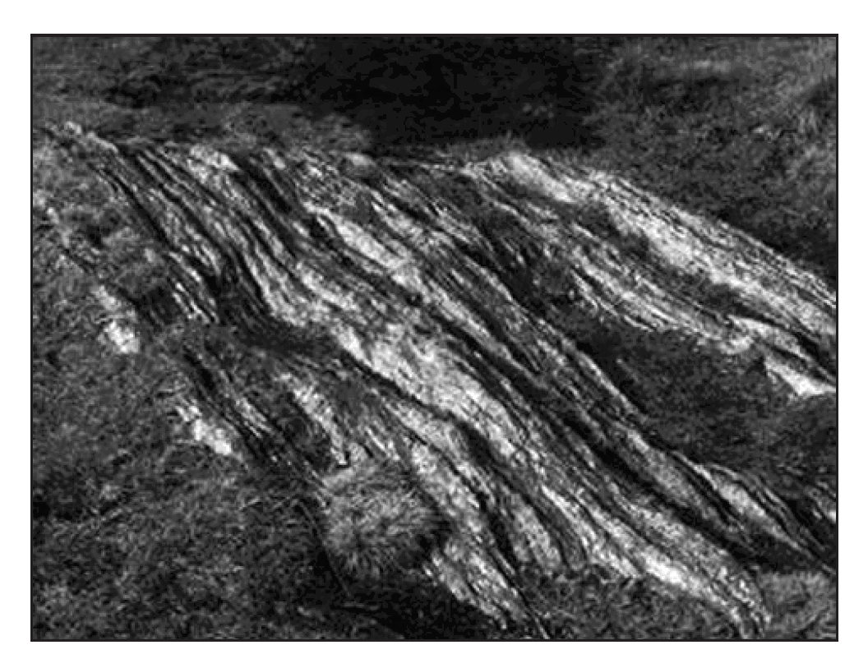
Based on the composition and foliated texture, which metamorphic rock can this best be identified as? _________________________________
Base your answers to questions 5 through 7 on the cross section below which represents the bedrock structure of a portion of the lithosphere. Letters A through D represent locations in the lithosphere.
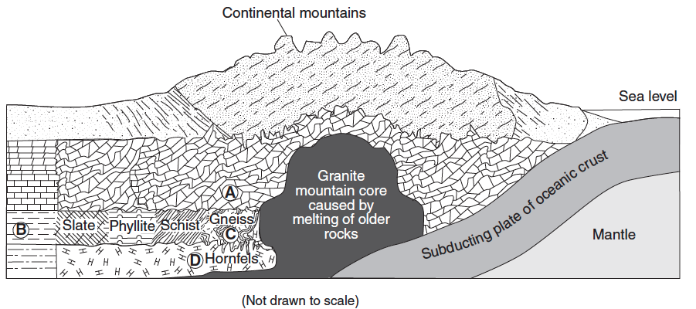
- Identify one of the most abundant minerals in the metamorphic rock at location A.

- Identify the grain size of the metamorphic rock at location D.

- Explain why the type of rock changes between locations B and C.

